**Model Development Phase**

|  |  |
| --- | --- |
| Date | 12 July 2024 |
| Team ID | SWTID1720077079 |
| Project Title | Wild Blueberry Yield Prediction |
| Maximum Marks | 4 Marks |

**Initial Model Training Code:**

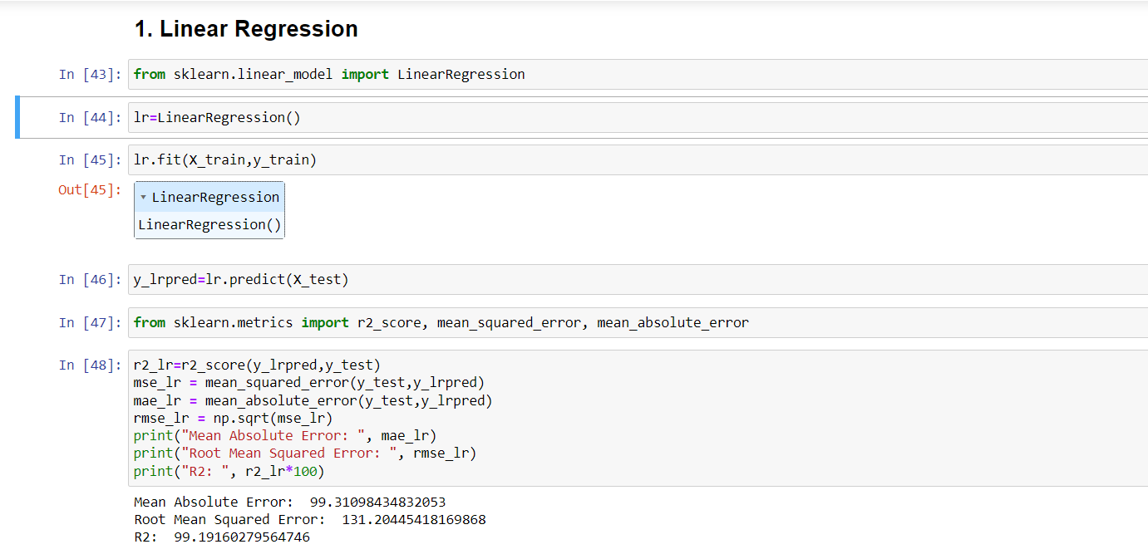

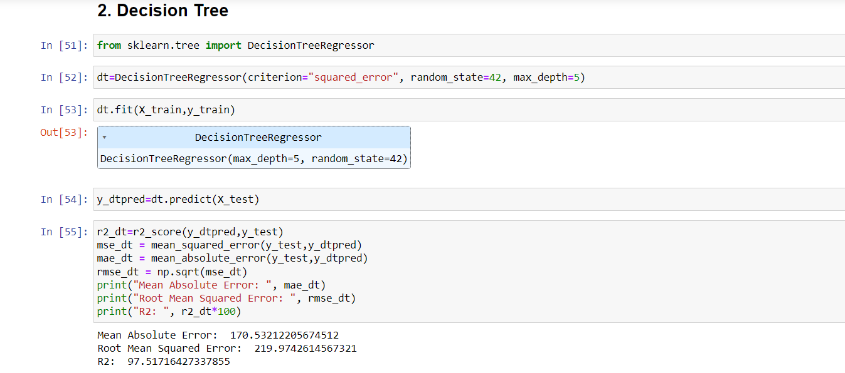

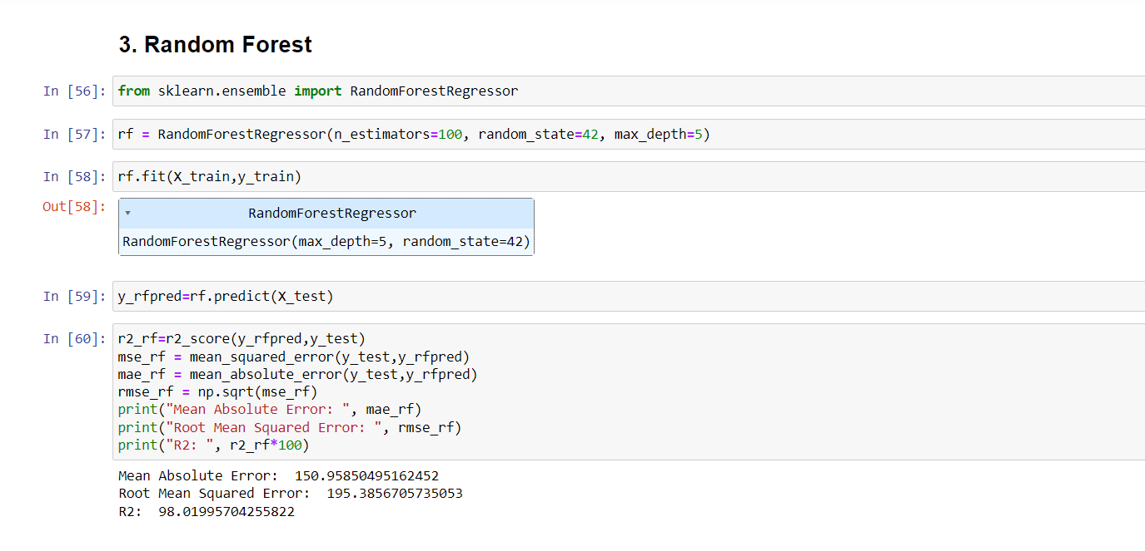

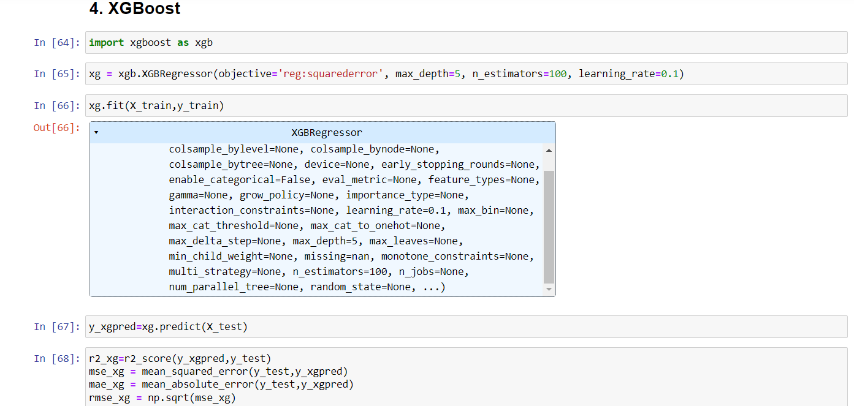

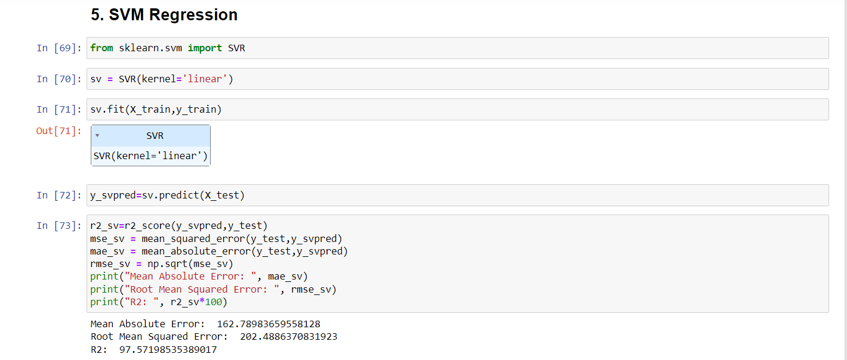

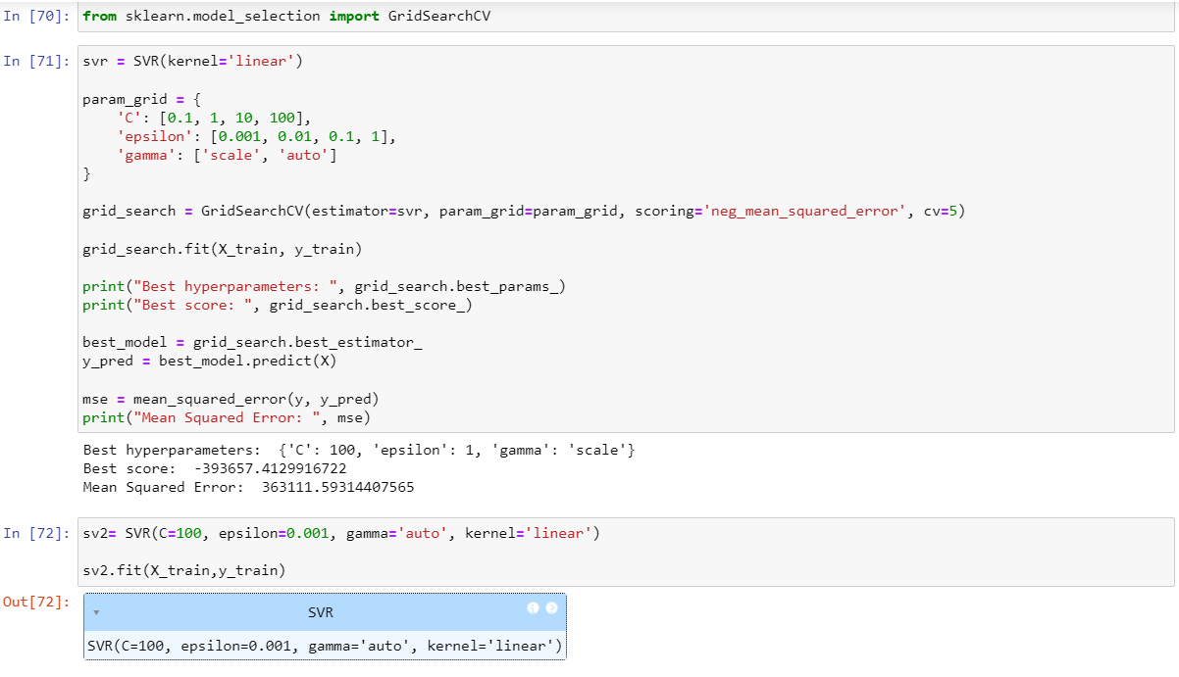

**Model Validation and Evaluation Report:**

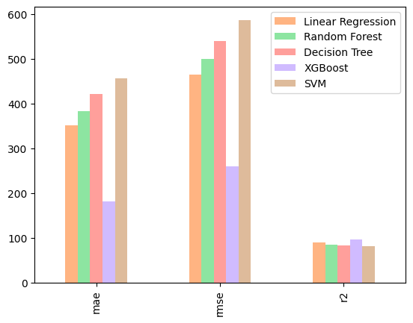

|  |  |
| --- | --- |
| **Model** | **Performance Metrics** |
| Linear Regression |  |
| Decision Tree |  |
| Random Forest |  |
| XGBoost |  |
| SVM Regression |  |